ГУО «Минский областной институт развития образования»

учитель английского языка
высшей категории
ГУО «Вилейская гимназия №2»
Балыко И.Л.,
сотрудники учебно-методического
отдела иностранных языков
ГУО «Минский областной ИРО»

Минск, 2012
INTERNATIONAL ORGANIZATIONS

An international organization is an organization with an international membership, scope, or presence. There are two main types:
- International nongovernmental organizations (INGOs): non-governmental organizations (NGOs) that operate internationally. These may be either:
  - International non-profit organizations. Examples include the International Olympic Committee, World Organization of the Scout Movement, Greenpeace, International Committee of the Red Cross and Médecins Sans Frontières.
  - International corporations, referred to as multinational corporations. Examples include The Coca-Cola Company, Sony, Nintendo, McDonalds, and Toyota.
- Intergovernmental organizations, also known as international governmental organizations (IGOs): the type of organization most closely associated with the term “international organization”, these are organizations that are made up primarily of sovereign states (referred to as member states). Notable examples include the United Nations (UN), Organization for Security and Co-operation in Europe (OSCE), Council of Europe (CoE), European Union (EU; which is a prime example of a supranational organization), European Patent Organization and World Trade Organization (WTO). The UN has used the term "intergovernmental organization" instead of "international organization" for clarity.
In addition, Global Public Policy Networks (GPPNs) may be considered a third category. These take various forms and may be made up of states and non-state actors. Non-state actors involved in GPPNs may include: intergovernmental organizations, states, state agencies, regional or municipal governments, in partnerships with non-governmental organizations, private companies, etc.

Ex.1. What do these abbreviations stand for? Decode them. Which of these organizations have you heard about?

1. EU 2. UN 3. EU 4. OSCE 5. WTO 6. IOC

Ex.2. Match the symbols or flags below to the organizations.
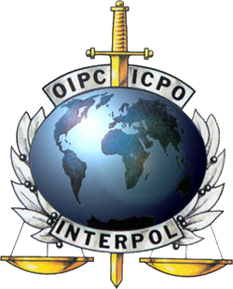
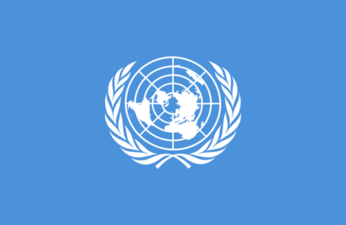
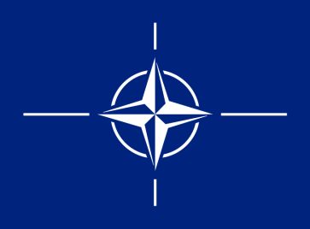
1. 2. 3.

4. 5. 6.

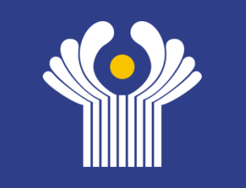
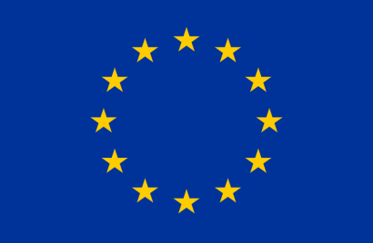

7. 8. 9.
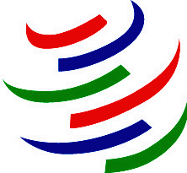
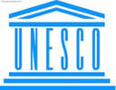
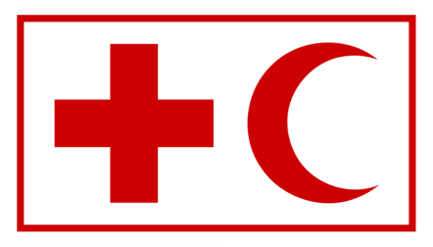
10. 11. 12.
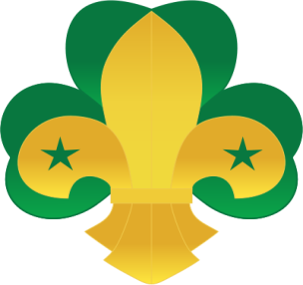
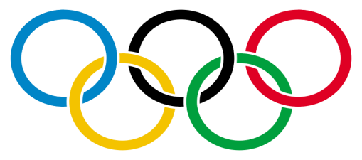

a) the International Olympic Committee b) the International Committee of the Red Cross
c) the United Nations Educational, Scientific and Cultural Organization
d) The North Atlantic Treaty Organization
e) Interpol f) World Organization of the Scout Movement
g) World Trade Organization h) Greenpeace
i) the Commonwealth of Independent States g) European Union
k) the United Nations l) Organization for Security and Co-operation in Europe

Ex.3. Discuss the questions in small groups.

1. Why do you think the International Organizations are necessary?
2. Which International Organizations is Belarus a member of?
3. In which ways can International Organizations help nations cope with their domestic problems?

Ex.4. Divide the International organizations you know into two groups. Fill in the table.

International nongovernmental organizations |  | Intergovernmental organizations
International non-profit organizations | International corporations

Ex. 5. Say why people create international organizations. Discuss the problem in groups. You may use the following.

international cooperation
spread of industrialization
progress in communication

to avoid dangers
to solve economic problems

transportation

COMMONWEALTH OF IINDEPENDENT STATES

The Commonwealth of Independent States (CIS) is a confederation, or alliance, created by Russia, Ukraine and Belarus.
Initiating the dissolution¹ of the Soviet Union in the autumn of 1991, the leaders of Russia, Belarus, and Ukraine met on December 8 in the Belovezhskaya Pushcha Natural Reserve, about 50 km north of Brest in Belarus, and signed an agreement establishing the CIS, which brought an end to the Soviet Union.
Soviet President Mikhail Gorbachev described this as an illegal and dangerous constitutional coup², but it soon became clear that the development could not be stopped and on December 21, 1991, the leaders of 11 of the 15 constituent republics of the USSR met in Alma-Ata, Kazakhstan, and signed the charter³, thus de facto ratifying the initial CIS treaty. The Soviet government had already recognized the independence of Estonia, Latvia, and Lithuania on September 6, 1991, and the three Baltic nations as well as Georgia refused to join CIS. The CIS charter stated that all the members were sovereign and independent nations and thereby effectively abolished the USSR. At the same time they announced that the new confederation would be open to all republics of the former Soviet Union, as well as other nations sharing the same goals.
Georgia joined the CIS in December 1993, bringing total membership to twelve states (the Baltic republics of Estonia, Lithuania, and Latvia never joined). It withdrew in 2008 (finalized 2009) following its conflict with Russia over South Ossetia. The organization had several goals, including coordination of members' foreign and security policies, development of a common economic space, fostering⁴ human rights and inter-ethnic concord⁵, maintenance⁶ of the military assets⁷ of the former USSR, creation of shared transportation and communications networks, environmental security, regulation of migration policy, and efforts to combat⁸ organized crime. The CIS had a variety of institutions through which it attempted to accomplish⁹ these goals: Council of Heads of State, Council of Heads of Government, Council of Foreign Ministers, Council of Defense Ministers, an inter-parliamentary assembly, Executive Committee, Anti-Terrorism Task Force, and the Interstate Economic Committee of the Economic Union.
The CIS is comparable to a very loose association of states and in no way comparable to a federation, confederation or supra-national organization such as the old European Community. It is more comparable to the Commonwealth of Nations. Although the CIS has few supranational powers, it is more than a purely symbolic organization, possessing coordinating powers in the realm of trade, finance, lawmaking and security. It has also promoted cooperation on democratization and cross-border crime prevention. As a regional organization, CIS participates in UN peacekeeping forces. Some of the members of the CIS have established the Eurasian Economic Community (EEC) with the aim of creating a full-fledged common market.
Although in a sense the CIS was designed to replace the Soviet Union, it was not and is not a separate state or country. Rather, the CIS is an international organization designed to promote cooperation among its members in a variety of fields. Its headquarters are in Minsk, Belarus. The chairman of the CIS is known as the executive secretary. All of the CIS's executive secretaries have been from Belarus or Russia. The current executive secretary since 5 October 2007 is Sergei Lebedev.
Over the years, its members have signed dozens of treaties and agreements, and some hoped that it would ultimately¹⁰ promote the dynamic development of ties among the newly independent post-Soviet states. By the late 1990s, however, the CIS lost most of its momentum and was victimized by internal rifts¹¹, becoming, according to some observers, largely irrelevant¹² and powerless.
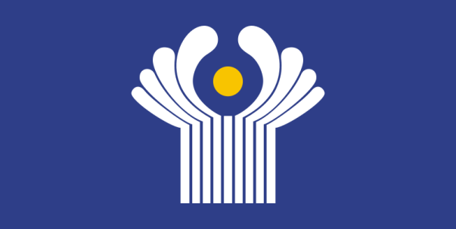
From its beginning, the CIS had two main purposes. The first was to promote what was called a "civilized divorce" among the former Soviet republics. Many feared the breakup of the Soviet Union would lead to political and economic chaos, if not outright conflict over borders. The earliest agreements of the CIS, which provided for recognition of borders, protection of ethnic minorities, maintenance of a unified military command, economic cooperation, and periodic meetings of state leaders, arguably¹³ helped to maintain some semblance¹⁴ of order in the region, although one should note that the region did suffer some serious conflicts (e.g., war between Armenia and Azerbaijan and civil conflicts in Tajikistan, Moldova, and Georgia).
The second purpose of the CIS was to promote integration among the newly independent states. On this score, the CIS had not succeeded. The main reason is that while all parties had a common interest in peacefully dismantling¹⁵ the old order, there has been no consensus among these states as to what (if anything) should replace the Soviet state. Moreover, the need to develop national political and economic systems took precedence in many states, dampening enthusiasm for any project of reintegration. CIS members have also been free to sign or not sign agreements as they see fit, creating a hodgepodge¹⁶ of treaties and obligations among CIS states.
One of the clearest failures of the CIS has been on the economic front. Although the member states pledged¹⁷ cooperation, things began to break down early on. By 1993, the ruble zone collapsed, with each state issuing its own currency. In 1993 and 1994, eleven CIS states ratified a Treaty on an Economic Union (Ukraine joined as an associate member). A free-trade zone was proposed in 1994, but by 2002 it still had not yet been fully established. In 1996 four states (Russia, Belarus, Krygyzstan, Kazakhstan) created a Customs Union, but others refused to join. All these efforts were designed to increase trade, but, due to a number of factors, trade among CIS countries has lagged behind targeted¹⁸ figures. More broadly speaking, economic cooperation has suffered because states had adopted economic reforms and programs with little regard for the CIS and have put more emphasis on redirecting their trade to neighboring European or Asian states.
Cooperation in military matters fared¹⁹ little better. The 1992 Tashkent Treaty on Collective Security was ratified by a mere six states. While CIS peacekeeping troops were deployed²⁰ to Tajikistan and Abkhazia (a region of Georgia), critics viewed these efforts as Russian attempts to maintain a sphere of influence in these states. As a "Monroeski Doctrine" took hold in Moscow, which asserted special rights for Russia on post-Soviet territory, and Russia used its control over energy pipelines to put pressure on other states, there was a backlash²¹ by several states against Russia, which weakened the CIS. After September 11, 2001, the CIS created bodies to help combat terrorism, and some hoped that this might bring new life to the organization.
Between 2003 and 2005, the so called “colour revolutions” have been taking place in three CIS member states — Georgia, Ukraine and Kyrgyzstan. The official slogan of these revolutions was the democratization of the society. The new government and political leaders of these countries has taken a clearly pro-Western stance²² contrasted to their predecessors. And now we can see that Ukraine, Georgia and Kyrgyzstan are quietly drifting away from the CIS.
In that time frame a number of statements have been made by member state officials, casting doubt on the potential and continued worth of the CIS.

¹dissolution распад ²coup [kH] удачный ход ³charter [`CRtq] хартия ⁴fostering [`fLstqrIN] одобрять, поощрять ⁵concord [`kONkLd] согласие ⁶maintenance [`meIntInqns] поддержка, содержание, поддержка ⁷assets [`xset] актив, имущество ⁸combat [`kOmbqt] бороться, сражаться ⁹accomplish [q`kOmplIS] выполнять ¹⁰ultimately [`AltImItlI] в конечном счете, в конце концов ¹¹rifts разрыв, разлад, трещина ¹²irrelevant [I`relIvqnt] неуместный, неподходящий ¹³arguably [`RgjuqblI] спорно ¹⁴semblance [`semblqns] видимость; подобие ¹⁵dismantling [dIs`mxntlIN] демонтирование ¹⁶hodgepodge [`hOGpOG] мешанина ¹⁷pledged [pleGd] ручались, обязывались ¹⁸targeted [`tRgItId] намеченные; поставленные целью ¹⁹fared [`fFqd] зд. шли ²⁰deployed [dI`plOId] развертывались ²¹backlash [`bxklxS] реакция ²²stance [stxns] позиция

EXERCISES

Ex.1. Make derivatives.

VERB → NOUN NOUN → ADJECTIVE

create constitution
dissolute permanence
ally civilization
observe association
cooperation creation
intergate defence
defend execution
agree illegality
announce danger
develop independence
execute government

Ex.2. Fill in the table.

NOUN | VERB | ADJECTIVE | ADVERB | NEGATIVE
 |  |  |  | NOUN | ADJECTIVE
 | ally
 | solute
danger
constitution
 | depend
member
environment
effect
 | maintain
 | compare
 | accomplish
symbol
democrat
 | vary
 | execution
victim
 | integrate
power

Ex.3. Find the odd word.

1. confederation, alliance, treaty, union
2. ratify, recognize, promote, obligation
3. proposal, aim, goal, purpose
4. Belarus, Kazakhstan, Lithuania, Russia

Ex.4. Complete the diagram with the main goals of the CIS.

development of a common economic space
GOALS

Ex.5. Join the two parts with OF according to the text.

1. The official slogan a) the CIS creation
2. The Commonwealth b) the society
3. The dissolution c) the constituent republics
4. The leaders OF d) these revolutions
5. The chairman e) Independent States
6. The main purposes f) the Soviet Union
7. The democratization g) the CIS

Ex.6. Make true word-combinations and translate them.

a)

1. permanent a) circumstances
2. associate b) nations
3. post-Soviet c) coup
4. foreign d) divorce
5. executive e) minister
6. civil f) revolutions
7. color g) war
8. civilized h) secretary
9. interior i) policy
10. illegal constitutional j) states
11. sovereign independent k) member
12. controversial l) membership

b)

Find synonyms.

1. creation a) annul
2. purpose b) previous
3. a large number c) found
4. dissolve d) alliance
5. agreement e) unite
6. nation f) reject
7. former g) formation
8. refuse h) aim, goal
9. join i) a lot of
10. confederation j) destroy
11. create k) treaty
12. abolish l) state

Ex.7. Find the words in the text that mean:

1) existing before, but not now;
2) the main building or offices used by a large organization
3) the combining of two or more things so that they work together effectively
4) someone, especially a man, who is in charge of a meeting or directs the work of a committee or organization
5) a statement of the principles, duties, and purposes of an organization
6) a formal agreement between two or more countries or governments
7) to make a written agreement official by signing it
8) to officially end a law, system etc. especially one that has existed for a long time
9) a machine, system etc. that existed before another one in a process of development
10) the state of having friendly relationship, so that you agree on things and live in peace
11) a group that is formed when two or more countries, groups etc. work together
12) the process by which something gradually becomes weaker and disappears

Ex.8. Fill in the table.

NAME OF ORGANIZATION
DATE OF CREATION
HEADQUARTERS CITY
NUMBER OF STATES
MEMBERSHIP. COUNTRIES
PURPOSE. AIMS
ACTIVITIES

Ex.9. Say in English.

1. республики бывшего Советского Союза 2. прекращать постоянное членство 3. его целью было
4. распад Советского Союза 5. “цивилизованный развод” 6. многие наблюдатели
7. штаб-квартира СНГ 8. исполнительный секретарь 9. подписали соглашение
10. открыта для всех бывших республик
11. нелегальный и опасный конституционный ход 12. внешняя политика
13. республики, составляющие СССР 14. упразднили СССР
15. супердержавы 16. бороться с организованной преступностью
17. в области торговли 18. надгосударственная организация
19. повышать сотрудничество между ее членами
20. полноправный общий рынок 21. испытывать серьезные конфликты
22. четкая прозападная позиция 23. медленно отдаляются от 24. бросило тень сомнения на
25. демократизация общества 26. погашая энтузиазм 27. переброска своей торговли

Ex.10. Connect the parts of the sentences correctly.

1. The CIS a. the executive secretary.
2. The CIS is comparable to b. in Minsk, Belarus.
3. The aim of the establishing the EEC c. was initiated by the European Union.
4. The purpose of the creation of the CIS d. the Commonwealth of Nations.
5. The CIS is headquartered e. is the creation of full-fledged common market
6. The chairman of the CIS is known as f. is a confederation.
7. The Eastern Partnership g. was to allow a “civilized divorce” between the Soviet
Republics.

Ex.11. Is it true or false?

1. An agreement establishing the CIS was an end to the Soviet Union.
2. The CIS consists of 15 member states.
3. The CIS charter stated that all the members were sovereign.
4. The new confederation is open to all countries, sharing the same goals.
5. Georgia never joined the CIS.
6. The CIS is comparable to a federation.
7. The CIS is a purely symbolic organization.
8. The CIS possesses coordinating powers in the realm of trade, finance, lawmaking and security.
9. The Eurasian Economic Community was established with the aim of creating a full-fledged common market.
10. The CIS was designed to replace the Soviet Union.
11. The CIS is a separate state with the capital and government.
12. The chairman of the CIS is its president.
13. By the late 1990s the CIS became largely irrelevant and powerless.

Ex. 12. Split into two teams and argue in favor and against the existence of the CIS.

FOR AGAINST

1. In my opinion The CIS ensures equality of all 1. As far as I know larger countries have more
member states privileges.
2. 2.
3. 3.
4. 4.
5. 5.

Ex.13. Answer these questions.

1. What is the CIS?
2. What countries were the founders of the CIS?
3. What countries are in the CIS at the moment?
4. When did Turkmenistan discontinue its permanent membership in the CIS?
5. What was the signal of the creation of CIS?
6. To your mind, was the creation of the CIS necessary for the countries of the former Soviet Union? Give your reasons.
7. How did Soviet President Mikhail Gorbachev describe the creation of the CIS?
8. What were the main purposes of the CIS creation?
9. What leaderships of three CIS member states were overthrown in a series of “color revolutions”?
10. When did Turkmenistan downgrade its CIS status to an associate member?
11. When was the dissolution of the Soviet Union initiated?
12. When was the initial CIS treaty ratified?
13. When did the Soviet government recognize the independence of Estonia, Latvia, and Lithuania?
14. Were Estonia, Latvia, and Lithuania the members of the CIS?
15. When did Georgia enter the CIS & why did it withdraw?
16. Why have some of the CIS members established the Eurasian Economic Community?
17. What documents have the member-states of the CIS signed since its formation?
18. Why didn’t the CIS succeed in promoting integration among the newly independent states?
19. What was one of the clearest failures of the CIS?
20. Why has economic cooperation between the CIS countries suffered?

TASKS

1. Think of the reasons for creation of the CIS.
2. What activities of the CIS would you put in the first place?
3. Imagine yourself as an executive secretary of the CIS. Name the problems you would deal with. Give the reasons.
4. Give your own opinion on the necessity of the CIS.
5. Express your opinion towards the necessity of the CIs.
Use:
- From my point of view…
- In my opinion …
- To tell the truth …
- Judging from …
- You can’t deny the fact that …

EUROPEAN UNION

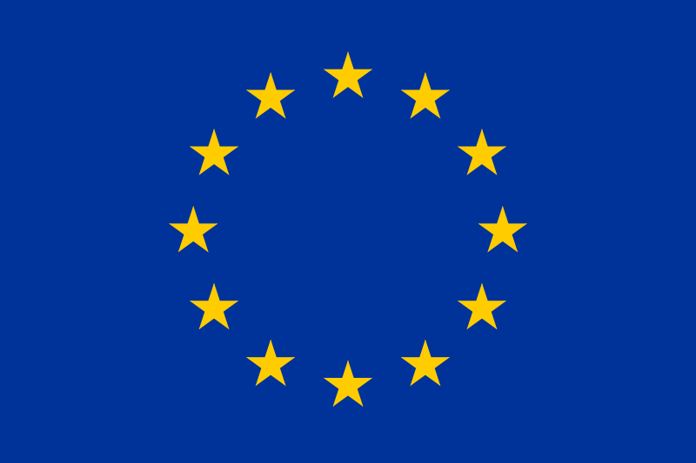
The European Union or the EU is an intergovernmental and supranational union of 27 European countries, known as member states.
The EU traces its origins from the European Coal and Steel Community (ECSC) and the European Economic Community (EEC) formed by six countries in the 1950s. In the intervening (переходной, промежуточный) years the EU has grown in size by the accession¹ of new member states, and in power by the addition of policy areas to its remit². The Maastricht Treaty or the Treaty on European Union established the European Union under its current name in 1993. However, many aspects of the Union existed before that date through a series of predecessor relationships, dating back to 1951.
The last amendment³ to the constitutional basis of the EU, the Treaty of Lisbon, came into force in 2009.
The European Union's activities cover all areas of public policy, from health and economic policy to foreign affairs and defense. However, the extent⁴ of its powers differs greatly between areas. Depending on the area, the EU may therefore resemble a federation, for example, on monetary affairs, agricultural, trade and environmental policy or a confederation, for example, on social and economic policy, consumer⁵ protection, home affairs, or even an international organization, for example, in foreign affairs.
The EU operates through a hybrid⁶ system of supranational (наднациональный, надгосударственный) independent institutions and intergovernmentally made decisions negotiated by the member states. Important institutions of the EU include the European Commission, the Council of the European Union, the European Council, the Court of Justice of the European Union, and the European Central Bank. The European Parliament is elected every five years by EU citizens.
The EU has developed a single market through a standardized system of laws which apply in all member states including the abolition⁷ of passport controls within the Schengen area. It ensures⁸ the free movement of people, goods, services, and capital, enacts (определять, вводить закон) legislation in justice and home affairs, and maintains common policies on trade, agriculture, fisheries and regional development. A monetary union, the eurozone, was established in 1999 and is currently composed of seventeen member states. Through the Common Foreign and Security Policy the EU has developed a limited role in external relations and defense. Permanent diplomatic missions have been established around the world and the EU is represented at the United Nations, the WTO, the G8 and the G-20.
A key activity of the EU is the establishment and administration of a common single market, consisting of a customs union, a single currency adopted by 17 of the 27 member states, a Common Agricultural Policy, a common trade policy, and a Common Fisheries Policy.
The most important EU institutions are the Council of the European Union, the European Commission, the European Parliament and the European Court of Justice. The EU headquarters are in Brussels, Belgium.
As to the enlargement⁹ of the EU there were five successive enlargements, with the largest occurring on May 1,2004, when 10 new member states joined.
Notwithstanding (Однако, тем не менее) Greenland doesn't enter the EU because it was granted home rule by Denmark in 1979 and left the European Community in 1985, following a referendum.
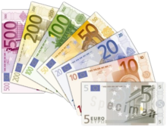
Romania and Bulgaria were the last two countries which joined the EU, so European Union has 27 member states at present. In time the European Union may grow to 30 member states. The process of enlargement is sometimes referred to as European integration.
In order to join the European Union, a state needs to fulfil the economic and political conditions generally known as the Copenhagen criteria, after the Copenhagen summit in June 1993. Also, according to the EU Treaty, each current member state and the European Parliament have to agree.
The European Union has 27 member states, an area of 3,892,685 km2 and over 500 million EU citizens. If it were a country, it would be the seventh largest in the world by area and the third largest by population after China and India. In 2010 the EU generated an estimated 26% (US$16.282 trillion) of the global economy, or 20% (US$15.170 trillion) when adjusted in terms of purchasing power parity
The European Union has land borders with 20 nations and sea borders with 31.

¹accession [xk`seSqn] прибавление, прирост ²remit компетенция ³amendment поправка, улучшение ⁴extent размер, круг ⁵consumer [kqnsjHmq] потребитель, потребительский
⁶hybrid [`haIbrId] смешанный ⁷abolition ["xbq`lISqn] отмена, упразднение
⁸ensures [In`Suqz] гарантирует, обеспечивает ⁹enlargement [In`lRGmqnt] увеличение, расширение

Ex.1. Add one word to make a word-combination.

1. foreign ___ 2. environmental ___ 3. consumer ___ 4. supranational ___
5. member ___ 6. a single ___ 7. monetary ___ 8. diplomatic ___
9. a single ___ 10. external ___ 11. European ___ 12. sea ___

Ex.2. Join the two parts with OF according to the text.

1. the accession a. predecessor relationships
2. administration b. public policy
3. abolishion c. the EU
4. the Court OF d. enlargement
5. the free movement e. new member states
6. the process f. a common market
7. the Council g. passport control
8. a series h. Justice
9. all areas i. people

Ex.3. Say in English.

1. тем не менее 2. покрывает все сферы государственной деятельности
3. в зависимости от сферы деятельности 4. создание и управление единым рынком
5. таможенный союз 6. расширение Евросоюза
7. единая валюта 8. Совет Евросоюза
9. одобрить это вступление 10. уступая только Китаю и Индии.
11. сухопутные границы 12. может напоминать федерацию
13. иногда называют евроинтеграцией 14. ключом всего существования Евросоюза является
15. монетарная политика 16. защита потребителя
17. отмена паспортного контроля 18. свободное передвижение людей

Ex. 4. Fill in the table.

NAME OF ORGANIZATION
DATE OF CREATION
HEADQUARTERS CITY
NUMBER OF STATES
MEMBERSHIP. COUNTRIES
PURPOSE. AIMS
ACTIVITIES

Ex. 5. Find synonyms.

1. nation a. self-governing
2. resemble b. decree
3. organization c. however
4. home d. state
5. treaty e. be similar
6. defend f. union / federation
7. notwithstanding g. domestic
8. independent h. agreement
9. enlargement i. protect
10. enact j. extension

Ex.6. Find the words in the text that mean:

1. conducted between or involving two or more governments
2. beyond the authority or jurisdiction of one national government
3. the act of entering upon or attaining to a union, office, right, etc.
4 the act of correction; an addition, alteration, or improvement to a document, etc.
5. annulment
6. the act or process of making laws; enactment
7. existing or intended to exist for an indefinite period
8. a meeting of chiefs of governments or other high officials

a. supranational b. summit c. abolishion d. intergovernmental
e. accession f. permanent g. legislation h. amendment

Ex. 7. Complete the diagram with the main goals of the EU. Get ready to speak about the EU activities.

GOALS / ACTIVITIES

single market

Ex. 8. Answer these questions.

1. What is the European Union?
2. When was the European Union established?
3. What were the purposes of the European Union creation?
4. What countries joined the European Union in 2004?
5. Do you want Belarus to join the European Union?
6. What was the largest enlargement of the EU?
7. How many enlargements were there?
8. When does Romania and Bulgaria join the EU?
9. How many member states were in the European Union in the very beginning?
10. How many member states are there in the European Union nowadays?
11. How many member states will there be in the European Union in 2011?
12. Is the EU a federation or confederation?
13. What should a state do in order to join the EU?
14. What is the area of the European Union?
15. What is the population of the EU?
16. How often is the Europarliament elected?
17. What are the most important EU institutions?

INTERPOL
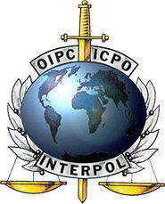
Interpol, more correctly the International Criminal Police Organization, was created in 1923 to assist international criminal police co-operation. The organization's new name was adopted in 1956, prior¹ to which it was known as the International Criminal Police Commission.
Interpol was founded in Austria in 1923 as the International Criminal Police Commission. The organization came under control of Nazi Germany when Germany declared the Anschluss, political union between Germany and Austria. The staff and facilities of Interpol were utilized (использовался) as an information gathering unit for the Gestapo, until the Nazi regime fell to Allied forces.
Senior military officials from Britain, France, Belgium and Scandinavia reorganized Interpol into today's organization.
The United States, after a period of isolationism, joined Interpol in 1961.
Interpol is the world's second largest international organization, after the United Nations; it currently has 188 member countries. It is financed by annual contributions from its member countries, which total about EUR 30 million; however, Europol receives million annually. The Organization is headquartered in Lyon, France, formerly headquartered in Saint Cloud, a town located in the vicinity of Paris. Since they are classified as an organization they can’t really make arrests.
Because of the politically neutral role Interpol must play, its Constitution forbids any involvement² in any political, military, religious, or racial crimes. Its work concentres primarily on public safety and terrorism, organized crime, illicit³ drug production and drug trafficking⁴, weapons smuggling⁵, trafficking in human beings, money laundering⁶, child pornography, financial and high-tech crime⁷, and corruption.
In October 2001, the Interpol General Secretariat employed a staff of 384, representing 54 different countries. That same month, Interpol began to change from a 9-to-5 agency to a 24-hour agency, making its work more efficient.
Its current Secretary-General is Ronald Noble, a former United States Under Secretary of the Treasury for Enforcement. Its current President is the Singapore Commissioner of Police Khoo Boon Hui; the President before that, Jackie Selebi, National Commissioner of the South African Police Service, held his term from 2004 till his resignation on 13 January 2008, after which he was charged in South Africa on three counts of corruption and one of defeating the course of justice, and replaced by Arturo Herrera Verdugo, current National Commissioner of Investigations Police of Chile and former vice president for the American Zone, who remained acting president until the organization meeting in October 2008.
Interpol holds one of the largest databases of unsolved crimes, criminal profiles, and stolen goods. Nations that are members of Interpol can access certain parts of the database and the official police of member nations are often encouraged to use information stored by Interpol if a major crime has occurred. Many criminals with international syndicates will likely have committed crimes in other countries making use of the database an extremely valuable utility.

¹prior [`praIqr] до, ранее ²involvement причастность, связь ³illicit [I`lIsIt] незаконный
⁴trafficking перевозка, транспортировка ⁵smuggling [`smAglIN] контрабанда
⁶laundering отмывание ⁷high-tech crime преступления, связанные с высокотехнологичными технологиями

Ex.1. Say in English.

1. было принято 2. попала под контроль 3. нацистский режим пал под напором
4. реорганизовали 5. ежегодные взносы 6. в предместьях
7. из-за политической нейтральности 8. запрещает вмешиваться
9. социальная безопасность 10. контрабанда оружия 11. торговля людьми
12. более эффективная 13. отмывание денег 14. содержит одну из самых больших базу данных 15. в основном сконцентрирована

Ex.2. Connect the parts of the sentences correctly.

1. to assist a. information stored by Interpol
2. to come b. arrests
3. to be utilized c. certain parts of the database
4. to be financed d. one of the largest databases
5. to make e. by annual contributions
6. to hold f. as an information gathering unit
7. to access g. under control
8. to use h. international criminal police

Ex. 3. Fill in the correct word.

Interpol was ___ in 1923. The organization’s new name was ___ in 1956. Interpol is the world's ___ ___ international organization. It is ___ by ___ contributions from its member states. The organization is ___ in Lyon, France. The Constitution of Interpol ___ any involvement in any political, military, religious, or racial crimes. Its work is ___ primarily on public ___, terrorism, ___ crime, etc. Interpol ___ one of the largest ___ of unsolved ___, criminal ___, and stolen ___.

Ex. 4. Fill in the table.

NAME OF ORGANIZATION
DATE OF CREATION
HEADQUARTERS CITY
NUMBER OF STATES
NUMBER OF STAFF EMPLOYED
PURPOSE. AIMS
ACTIVITIES

Ex. 5. Find the words in the text that mean:

1. a group of people employed by a company, organization, etc., for executive, clerical, sales work, etc.
2. to make practical or worthwhile use of
3. to change the way (something) is organized
4. to provide or obtain funds, capital, or credit for
5. once a year
6. not siding with any party to a war or dispute
7. to prohibit in a forceful or authoritative manner
8. an evil act; unlawful acts in general
9. freedom from danger or risk of injury
10. to import or export (prohibited or dutiable goods) secretly or illegally
11. moral perversion; depravity; dishonesty; putrefaction or decay

a. corruption b. utilize c. annually d. forbid e. smuggle f. neutral g. reorganize
h. safety i. crime j. finance k. staff

Ex. 6. Complete the diagram with the main activities of Interpol. Get ready to speak about the Interpol activities.

ACTIVITIES

Public safety

Ex. 7. Express your point of view on the following problems:

- struggle against organized crime
- drug trafficking
- money laundering
- illicit drug production
- weapons smuggling
- trafficking in human beings
- terrorism
- financial and high-tech crime
- corruption
- child pornography

Ex.8. Answer the questions.

l. What is Interpol?
2. When was Interpol established?
3. What were the main purposes of Interpol creation?
4. What activity limitations does Interpol have?
5. What are the main activities of Interpol?
6. When did the United States join Interpol?
7. How many member countries are there in the organization at the moment?
8. What is forbidden for Interpol?
9. Where is the Organization headquartered?

GREENPEACE

In 1971, motivated by their vision of a green and peaceful world, a small team of activists set sail from Vancouver, Canada, in an old fishing boat.
These activists, the founders of Greenpeace, believed a few individuals could make a difference.
Their mission was to “bear witness” to US underground nuclear testing at Amchitka, a tiny island off the West Coast of Alaska, which is one of the world's most earthquake-prone regions (регионы, склонные к землетрясениям). Amchitka was the last refuge for 3000 endangered sea otters, and home to bald eagles, peregrine falcons¹ and other wildlife.
Even though their old boat was intercepted² before it got to Amchitka, the journey sparked a flurry³ of public interest. The US still detonated⁴ the bomb, but the voice of reason had been heard. Nuclear testing on Amchitka ended that same year, and the island was later declared a bird sanctuary⁵.
In a few years Greenpeace spread to several countries and started to campaign on other environmental issues such as commercial whaling and toxic waste. In the late 1970s the different regional Greenpeace groups formed Greenpeace International to oversee⁶ the goals and operations of the regional organizations globally. Greenpeace received international attention during the 80s when the French intelligence agency bombed the Rainbow Warrior in Auckland's Waitemata Harbor, one of the most well-known vessels⁷ operated by Greenpeace, killing one. In the following years Greenpeace evolved⁸ into one of the largest environmental organizations in the world.
Greenpeace is known for its direct actions and has been described as the most visible⁹ environmental organization in the world. Greenpeace has raised environmental issues to public knowledge, influenced both the private and the public sector. Greenpeace has also been a source of controversy¹⁰; its motives and methods have received criticism and the organization's direct actions have sparked legal actions against Greenpeace activists.
Today, Greenpeace is an international ecological organization that has 2.8 million supporters worldwide, and national as well as regional offices in 41 countries. Its headquarters are based in Amsterdam, the Netherlands.
Greenpeace is a non-profit (некоммерческая, не предназначенная для получения прибыли) organization and nongovernmental. It unites people of different colors living in different continents and speaking different languages. The common mission of this organization is preserving life on the earth in its full variety.
Greenpeace states its goal is to "ensure the ability of the Earth to nurture¹¹ life in all its diversity" and focuses its work on worldwide issues such as global warming, deforestation, overfishing (чрезмерный промысел), commercial whaling¹² and anti-nuclear issues. Greenpeace uses direct action, lobbying and research to achieve its goals.
Greenpeace does not accept donations¹³ from governments, corporations or political parties but relies on contributions from individual supporters and foundation grants. Greenpeace does not support any political party. Nevertheless, its members carry on a dialogue with all political forces and struggle for approving and passing laws for the welfare¹⁴ of our environment.
As a global organization, Greenpeace focuses on the most crucial¹⁵ worldwide threats to our planet's biodiversity¹⁶ and environment. It campaigns to stop climate change, save the oceans, stop whaling, say no to genetic engineering, stop the nuclear threat, eliminate¹⁷ toxic chemicals.
The goal of Greenpeace is to expose¹⁸ environmental criminals and to challenge¹⁹ government and corporations when they fail to live up to their mandate (поручение, наказ) to safeguard²⁰ our environment and our future.

¹peregrine falcon обыкновенный сокол ²was intercepted было перехвачено ³flurry шквал
⁴detonate взрывать ⁵sanctuary святилище ⁶oversee наблюдать, надзирать, следить
⁷vessel судно ⁸evolved развился ⁹visible видный ¹⁰controversy дебаты, дискуссия, полемика, спор ¹¹nurture питать, насыщать ¹²whaling охота на китов ¹³donations денежные пожертвования ¹⁴welfare благополучие, благосостояние ¹⁵crucial ключевой, критический, решающий ¹⁶biodiversity биологическое разнообразие ¹⁷eliminate устранять
¹⁸expose разоблачать ¹⁹challenge ставить под сомнение, оспаривать ²⁰safeguard защищать

Ex.1. Say in English.

1. отправились в плавание 2. рыболовецкое судно 3. свидетельствовать
4. регионы, наиболее часто подвергающиеся землетрясениям 5. последнее прибежище
6. ядерные испытания 7. начал проводить компанию 8. вопросы по окружающей среде
9. токсические отходы 10. в конце семидесятых годов 11. привлек международное внимание
12. разведывательное управление 13. прямые действия 14. поднял вопросы
15. вызывать правовые действия 16. сторонники по всему миру 17. единая миссия
18. сохранение жизни 19. во всем ее многообразии 20. мировые вопросы
21. достигать цели 22. полагается на пожертвования 23. принятие законов
24. положить конец климатическим изменениям

Ex.2. Is it true or false? Correct the sentences that are not right.

1. Greenpeace is an international nongovernmental organization.
2. The founders of Greenpeace believed a few individuals could make a difference.
3. The West Coast of Alaska is one of the world's most earthquake-prone regions.
4. The journey of the first activists didn’t attract public attention.
5. The voice of reason hadn’t been heard.
6. In a few years Greenpeace started to campaign on other environmental issues such as commercial whaling and toxic waste.
7. Greenpeace received international attention during the 80s.
8. Greenpeace isn’t a large organization.
9. Greenpeace is known for its direct actions.
10. Greenpeace is an international ecological organization that has a lot of supporters worldwide.
11. It unites people of different colors living in different continents and speaking different languages.
12. The common mission of this organization is preserving life on the earth in its full variety.
13. Greenpeace accepts donations from governments, corporations and political parties.
14. It campaigns to stop climate change, save the oceans, stop whaling, say no to genetic engineering, stop the nuclear threat, eliminate toxic chemicals.

Ex. 3. Fill in the table.

NAME OF ORGANIZATION
DATE OF CREATION
HEADQUARTERS CITY
NUMBER OF STATES
NUMBER OF SUPPORTERS WORLDWIDE
PURPOSE. AIMS
ACTIVITIES

Ex.4. Make word combinations and translate them.

1. peaceful a. agency
2. nuclear b. warming
3. endangered c. actions
4. environmental d. life
5. toxic e. attention
6. regional f. world
7. global g. testing
8. preserving h. animals
9. direct i. organizations
10. international j. waste
11. intelligence k. issues

Ex. 5. Add one word to make correct phrases.

1. climate ___ 2. genetic ___ 3. foundation ___ 4. fishing ___
5. bear ___ 6. earthquake-prone ___ 7. commercial ___ 8. public ___
9. nongovernmental ___ 10. common ___ 11. accept ___ 12. underground nuclear ___

Ex. 6. Insert the right preposition. Then make up sentences.

1. to focuse ___ the most crucial worldwide threats 2. to rely ___ contributions
3. to be known ___ 4. to carry ___ a dialog 5. to live ___ ___ a mandate

Ex. 7. Find synonyms.

1. boat a. variety
2. tiny b. mutual
3. refuge c. reach
4. journey d. conserve
5. issue e. adherent
6. goal f. vessel
7. diversity g. small
8. achieve h. shelter
9. preserve i. voyage
10. common j. question
11. supporter k. aim

Ex.8. Find the words in the text that mean:

1. fulfill (an expectation, obligation, principle, etc.)
2. shelter or protection, as from the weather or danger
3. the act of giving, esp. to a charity
4. the external surroundings in which a plant or animal lives, which tend to influence its development and behavior
5. garbage, rubbish or trash; the useless products
6. the study of the relationships between living organisms and their environment
7. applying or extending throughout the world; universal
8. any center or building from which operations are directed, as in the military, the police, etc.
9. keep safe from danger or harm; protect
10. the state or quality of being different or varied

a. preserve b. donation c. headquarters d. ecology e. diversity
f. live up (to) g. refuge h. environment i. worldwide j. waste

Ex.9. Prove that Greenpeace campaigns:

- to stop climate change
- to save the oceans
- to stop industrial whaling
- to protect endangered animals and wildlife on the whole

Ex. 10. Discuss in pairs direct actions of Greenpeace to save wildlife on the planet.

Use:

- to create reserves and national parks
- to plant trees and bushes
- to fight against killing wild animals
- to protest against deforestation and cutting down rainforests

Ex. 11. Find the odd one out and give your reason.

1. otter, eagle, falcon, whale, cornflower
2. activist, supporter, individual, organization, criminal
3. preserve, detonate, protect, safeguard, defend
4. deforestation, nuclear threat, protection, global warming, toxic chemicals
5. visible, knowledge, refuge, donation, threat

Ex.12. Answer the questions.

1. When did a small team of activists set sail from Vancouver, Canada?
2. Who were the founders of Greenpeace?
3. What was their mission?
4. Who lived at Amchitka?
5. What did the journey spark?
6. Was nuclear testing on Amchitka ended?
7. What was the island declared?
8. What can you say about Greenpeace today?
9. Does Greenpeace have many supporters?
10. Where are its headquarters based?
11. What is the common mission of this organization?
12. What do you know about political activities of Greenpeace?
13. What does Greenpeace focus on?
14. What does it campaign?
15. What is the goal of Greenpeace?

Ex. 13. Compare the organizations.

 | GREENPEACE | THE COMMONWEALTH OF INDEPENDENT STATES
Type of the organization
Date of creation
Headquarters (City, country)
Main goals

ТНЕ UNITED NATIONS

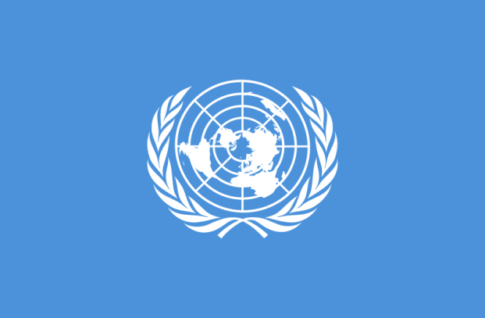
The United Nations (UN) is an international organization whose stated aims are facilitating cooperation in international law, international security, economic development, social progress, human rights, and achievement of world peace. Additionally, its purposes call for the development of friendly relations among nations based on equal rights and self-determination of peoples and, through international соoperation, the solution of problems of an economic, social, cultural and humanitarian nature.
The United Nations is the meeting-place where representatives of all member states — great and small, rich and poor, with varying political views and social systems — have а voice and an equal vote in shaping а common course of action.
The United Nations has played and continues to play, an active role in reducing tension¹ in the world, preventing conflicts and putting an end to fighting already under way.
The term “United Nations” was coined (был придуман) by Franklin D. Roosevelt during World War II, to refer to the Allies². Its first formal use was in the January 1, 1942 Declaration by the United Nations, which committed the Allies to the principles of the Atlantic Charter and pledged³ them not to seek⁴ a separate peace with the Axis powers. Thereafter⁵, the Allies used the term “United Nations Fighting Forces” to refer to their alliance.
The idea for the United Nations was elaborated⁶ in declarations signed at the wartime Allied conferences in Moscow, Cairo, and Tehran in 1943. From August to October 1944, representatives of France, the Republic of China, the United Kingdom, the United States, and the USSR met to elaborate the plans in Washington, D.C. Those and later talks produced proposals outlining⁷ the purposes of the organization, its membership and organs, as well as arrangements to maintain international peace and security and international economic and social cooperation. These proposals were discussed and debated by governments and private citizens worldwide.
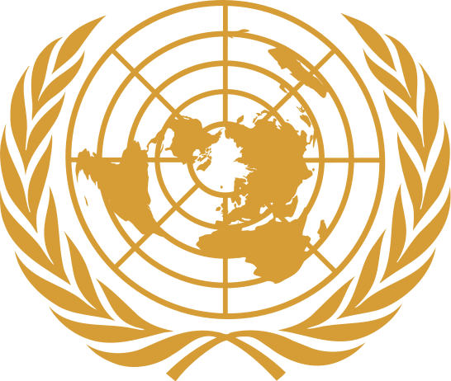
On April 25, 1945, the United Nations Conference on International Organizations began in San Francisco. In addition to the Governments, a number of non-government organizations were invited to assist in the drafting⁸ of the charter. The 50 nations represented at the conference signed the Charter of the United Nations two months later on June 26. Poland, which was not represented at the conference, but for which a place among the original signatories⁹ had been reserved, added its name later, bringing the total of original signatories to 51. The UN came into existence on October 24,1945, after the Charter had been ratified by the five permanent members of the Security Council — Republic of China, France, the Soviet Union, the United Kingdom, and the United States — and by a majority of the other 46 signatories.
The UN was founded in 1945 after World War II to replace the League of Nations, to stop wars between countries, and to provide a platform for dialogue. It contains multiple subsidiary¹⁰ organizations to carry out its missions.
There are currently 193 member states, including every internationally recognized sovereign state in the world but the Vatican City. From its offices around the world, the UN and its specialized agencies decide on substantive¹¹ and administrative issues in regular meetings held throughout the year.
The organization has six principal organs: the General Assembly (the main deliberative¹² assembly); the Security Council (for deciding certain resolutions for peace and security); the Economic and Social Council (for assisting in promoting international economic and social cooperation and development); the Secretariat (for providing studies, information, and facilities needed by the UN); the International Court of Justice (the primary judicial¹³ organ); and the United Nations Trusteeship¹⁴ Council (which is currently inactive). Other prominent UN System agencies include the World Health Organization (WHO), the World Food Program (WFP) and United Nations Children's Fund (UNICEF). The UN's most visible public figure is the Secretary-General, currently Ban Ki-moon of South Korea, who attained the post in 2007.
The Court has its seat at the Hague, Netherlands. All other organs are based at the United Nations Headquarters in New York. Members of the General Assembly talk to each other in many languages, but officially there are only six - Arabic, Chinese, English, French, Russian and Spanish.
The Secretariat services the other organs of the Unite Nations and administers the programs and policies laid down by them. Over 20,000 men and women are employed by the United Nations with about one-third of them at the Head quarters and the other two-thirds stationed around the globe. Staff members are recruited¹⁵ primarily from member states and are drawn from more than 140 nations. As international civil servants, each takes an oath not to seek or receive instructions from any government or outside authority.
Working for the United Nations, mostly "behind the scenes" at the Headquarters, are linguists, economists, editors, social scientists, legal experts, librarians, journalists, statisticians, broadcasters, personnel officers, administrators and experts in all the varied fields of activity covered by the United Nations. They prepare the reports and studies¹⁶ requested by various bodies of the United Nations; they issue press releases and produce publications, broadcasts and films giving information about the United Nations; and they perform the administrative duties needed to implement¹⁷ resolutions adopted by the various organs. In addition, there are stenographers, clerks, engineers and technicians, tour guides and also а body of security officers in blue-grey uniforms who are responsible for the security of the United Nations Headquarters. At the head of the Secretariat is the Secretary-General.
The United Nations headquarters building was constructed in New York City in 1949 and 1950 beside the East River on land purchased by an 8.5 million dollar donation from John D. Rockefeller, Jr., and designed by architect Oscar Niemeyer. UN headquarters officially opened on January 9, 1951. While the principal headquarters of the UN are in New York, there are major agencies located in Geneva, The Hague, Vienna, Montreal, Bonn, Nairobi.
The United Nations Organization Secretariat occupies the higher building. The General Assembly is held in the lower building.
The organization is financed from assessed¹⁸ and voluntary contributions from its member states.
UN membership is open to all peace-loving states that accept the obligations of the UN Charter and, in the judgement of the organization, are able and willing to fulfil these obligations.

¹tension напряженность ²Allies союзники ³pledge обязывать; давать слово ⁴seek искать
⁵thereafter после этого, впоследствии ⁶elaborate – тщательно, детально, скрупулезно разработать (продумать) ⁷outlining очерчивая, обрисовывая ⁸drafting составление ⁹signatories подписавшаяся сторона (государство) ¹⁰subsidiary второстепенный, вспомогательный; дочерний ¹¹substantive материально-правовой ¹²deliberative совещательный ¹³judicial судебный ¹⁴Trusteeship попечительский, опекунский ¹⁵recruit набирать для службы ¹⁶studies исследования ¹⁷implement выполнять ¹⁸assessed определенный

Ex.1. Say in English.

1. его первое формальное использование 2. положить конец (чему-либо) 3. связал союзников с принципами Атлантического договора 4. государства Оси 5. была выработана 6.для принятия участия в составлении устава 7. страны-основательницы 8. изложенные цели которой 9. права человека 10. с различными политическими взглядами 11. общий курс действий 12. уменьшение напряженности 13. предотвращение конфликтов 14. чтобы прекратить войны между странами 15. многочисленные вспомогательные организации 16. на земле, приобретенной за

Ex.2. Is it true or false? Correct the sentences that are not right.

1. The United Nations is an international.
2. The main goal of the UN is to find criminals who had committed serious crimes.
3. Its work concentres primarily on public safety, terrorism and organized crime.
4. The UN is the second largest organization in the world.
5. The main aims of the UN are facilitating cooperation in international law, international security, economic development, social progress, human rights, and achievement of world peace.
6. Various UN organizations help countries in the solution of problems of an economic, social, cultural and humanitarian nature.
7. The United Nations plays an active role in reducing tension in the world and preventing conflicts among nations.
8. The term “United Nations” was invented by American President.
9. The 50 nations represented at the conference in Tehran signed the Charter of the United Nations on June 26.
10. There were 50 total original signatories of the UN Charter.
11. The UN was founded before World War II.
12. The UN was founded to replace the League of Nations, to stop wars between countries, and to provide a platform for dialogue.
13. The UN contains multiple subsidiary organizations.
14. The Vatican City is the member of the UN.
15. All the UN organs are based in New York.
16. No more than 200 people are employed by the United Nations.
17. The organization is financed from assessed and voluntary contributions from its member states.
18. No one country can join the UN nowadays.

Ex. 3. Find synonyms.

1. security a. main / chief
2. purpose b. carry out / perform
3. representative c. duty / responsibility
4. tension d. gift
5. reduce e. opinion
6. prevent f. perform
7. seek g. independent
8. proposal h. residence
9. cooperation i. safety
10. agency j. objective
11. seat k. delegate
12. employ l. stress
13. implement m. lower / lessen
14. purchase n. avert
15. donation o. look for
16. obligation p. organization
17. fulfill q. suggestion
18. principal r. interaction
19. view s. buy
20. sovereign t. hire

Ex. 4. Fill in the table.

NAME OF ORGANIZATION
DATE OF CREATION
HEADQUARTERS CITY
NUMBER OF STATES
OFFICIAL LANGUAGES
PRINCIPAL ORGANS
PURPOSE. AIMS
ACTIVITIES

Ex. 5. Add one word to make correct phrases.
a)
1. ___ security 2. ___ rights 3. ___ relations 4. ___ -place
5. ___ views 6. ___ vote 7. ___ tension 8. ___ conflicts
9. ___cooperation 10. ___ signatories 11. ___ agencies 12. ___ organs
13. ___ servants 14. ___ releases 15. ___ contributions 16. ___ obligations

b)
1. international ___ 2. friendly ___ 3. member ___ 4. social ___
5. active ___ 6. Axis ___ 7. permanent ___ 8. subsidiary ___
9. public ___ 10. staff ___ 11. principal ___ 12. voluntary ___

Ex.6. Join the two parts with OF according to the text. Translate the word combinations.

1. achievement a. non-government organizations
2. development b. all member states
3. the solution c. peoples
4. the purposes d. the UN Charter
5. the International Court OF e. activity
6. various fields f. world peace
7. the obligations g. friendly relations
8. self-determination h. problems
9. representatives i. the organization
10. a number j. Justice

Ex. 7. Complete the diagram with the main aims of the United Nations. Get ready to speak about the aims of the UN.

economic development
AIMS

Ex.8 . Insert the right preposition. Then make up sentences.

to | on | out | into | for

1. call ___ 2. be based ___ 3. put an end ___ 4. refer ___
5. in addition ___ 6. come ___ existence 7. decide ___ 8. be responsible ___
9. the conference ___ International Organizations 10. carry ___ the mission

Ex.9. Find the words in the text that mean:

1. the act or process of solving a problem; a specific answer to or way of answering a problem
2. a moral or legal requirement, duty
3. having identical privileges, right, status, etc.
4. opinion, thought
5. a situation or condition of hostility, suspense, or uneasiness
6. acting for or representing a constituency or the whole people in the process of government
7. to keep from happening, esp. by taking precautionary action
8. a formal agreement or pact, esp. a military one, between two or more countries to achieve a particular aim
9. an offer; something offered as a plan
10. the fundamental principles of an organization, constitution
11. a person who has signed a document such as a treaty or contract or an organization, state, etc., on whose behalf such a document has been signed
12. existing or intended to exist for an indefinite period; not expected to change for an indefinite time; not temporary
13. the greater number or part of something
14. independent of outside authority
15. to obtain (goods, etc.) by payment

a. tension b. proposal c. permanent d. purchase e. alliance
f. view g. charter h. obligation i. signatory j. sovereign
k. solution l. majority m. prevent n. equal o. representative

Ex.10. Fill in the table.

NOUN | VERB | ADJECTIVE | POSSIBLE PREFIXES
 |  | secure
 | achieve
 | solve
humanity
 | represent
 | prevent
 |  | formal
 | ally
 | declare
security
 |  | governmental
 | exist
place
donation
 | subside
 |  | sovereign
 |  | active
 | serve
 | purpose
 | maintain

Ex. 11. Discuss in small groups how the UN helps promote peace among nations. Use the key words.

reduce tension
prevent
conflicts
friendly relations

stop wars
solution of
problems

Ex. 11. Answer the questions.

1. What is the UN?
2. What are the main goals of the UN?
3. What role does the UN play?
4. Who coined the term “United Nations”?
5. When was the first formal use of the term “United Nations”?
6. Why was the UN founded?
7. What organization did the UN replace?
8. How many nations were at the conference in San Francisco in 1945?
9. Why are there 51 founders of the UN instead of 50?
10. What country was not represented at the conference?
11. What are the principal organs of the UN?
12. How many nations are there in the UN at present?
13. What are the official languages of the UN?
14. Where is the Court of Justice seated?
15. When and where was the United Nations headquarters building constructed?
16. Who donated this construction?
17. Who designed the United Nations headquarters building?

WORLD TRADE ORGANIZATION

According to the World Trade Organization (WTO), its goal is to help producers of goods and services, exporters, and importers conduct their business. This international organization accomplishes¹ this mainly by helping countries establish and agree upon trade rules. Without such an organization, it is likely that trade relations between foreign entities could be difficult, unfair², and inconsistent³.
The World Trade Organization was created in 1995 and has three official languages: French, English and Spanish. The organization has hundreds of members around the globe, however, and aims to work in the best interest of all of them. Most decisions made by the WTO are matters of consensus⁴. This means that all members agree upon them.
A trade agreement usually contains both the rights and obligations of the agreeing parties. WTO agreements can generally be divided into two categories. Multilateral agreements refer to those that all World Trade Organization members have agreed to. Plurilateral agreements are those that only some members have agreed to.
Different countries tend to have different cultures. Many people in business realize that culture can be a major factor in determining how affairs are conducted. Other factors such as previous experiences, both good and bad, can determine⁵ the business decisions that are made. These are just two of many examples of factors that could cause trade barriers or trade inconsistencies if such business arrangements were left to the whim⁶ of individuals.
One thing that the World Trade Organization aims to do is normalize trade. This means that certain practices should be kept consistent⁷. For example, the organization may secure agreements among trade partners that prevent politics from playing a role in the initiation or rise of tariffs.
In addition to easing trade transactions, the World Trade Organization also aims to eliminate discrimination from international exchange. This can produce the dual benefits of allowing producers access to foreign markets and allowing consumers access to foreign goods. This can also prevent substantial economic growth for some while economic growth is unfairly or unethically inhibited for others.
Another duty of the World Trade Organization is to act as a monitoring agency. This means the organization seeks to ensure that agreeing parties uphold⁸ their decisions. Members often have a great deal of liberty and flexibility to form their own policies, despite the agreements they sign. The WTO is governed by a ministerial conference, meeting every two years; a general council, which implements the conference's policy decisions and is responsible for day-to-day administration; and a director-general, who is appointed by the ministerial conference. The WTO may review national policies and work with members on areas that may inhibit⁹ trade, smother growth, or potentially violate agreements.

Functions

Among the various functions of the WTO, these are regarded by analysts as the most important:

- It oversees the implementation, administration and operation of the covered agreements.
- It provides a forum for negotiations and for settling disputes.
Additionally, it is the WTO's duty to review and propagate the national trade policies, and to ensure the coherence and transparency of trade policies through surveillance in global economic policy-making. Another priority of the WTO is the assistance of developing, least-developed and low-income countries in transition to adjust to WTO rules and disciplines through technical cooperation and training.
The WTO is also a center of economic research and analysis: regular assessments of the global trade picture in its annual publications and research reports on specific topics are produced by the organization. Finally, the WTO cooperates closely with the two other components of the Bretton Woods system, the IMF and the World Bank.

The WTO has 153 members, representing more than 97% of the world's population, and 31 observers. In addition to states, the European Union is also a member. WTO members do not have to be full sovereign nation-members. Instead, they must be a customs territory with full autonomy in the conduct of their external commercial relations.
The WTO's headquarters is at the Centre William Rappard, Geneva, Switzerland.

Accession and membership

The process of becoming a WTO member is unique to each applicant country, and the terms of accession are dependent upon the country's stage of economic development and current trade regime. The process takes about five years, on average, but it can last more if the country is less than fully committed to the process or if political issues interfere. As is typical of WTO procedures, an offer of accession is only given once consensus is reached among interested parties.
A country wishing to accede to the WTO submits an application to the General Council, and has to describe all aspects of its trade and economic policies that have a bearing on WTO agreements. The application is submitted to the WTO in a memorandum which is examined by a working party open to all interested WTO Members.
After all necessary background information has been acquired, the working party focuses on issues of discrepancy between the WTO rules and the applicant's international and domestic trade policies and laws. The working party determines the terms and conditions of entry into the WTO for the applicant nation, and may consider transitional periods to allow countries some leeway in complying with the WTO rules.
The final phase of accession involves bilateral negotiations between the applicant nation and other working party members regarding the concessions and commitments on tariff levels and market access for goods and services. The new member's commitments are to apply equally to all WTO members under normal non-discrimination rules, even though they are negotiated bilaterally.
When the bilateral talks conclude, the working party sends to the general council or ministerial conference an accession package, which includes a summary of all the working party meetings, the Protocol of Accession (a draft membership treaty), and lists ("schedules") of the member-to-be's commitments. Once the general council or ministerial conference approves of the terms of accession, the applicant's parliament must ratify the Protocol of Accession before it can become a member.

¹accomplish достигать ²unfair несправедливый ³inconsistent непоследовательный, противоречивый, несовместимый ⁴consensus согласие, единодушие ⁵determine определять, устанавливать ⁶whim [wIm] прихоть, каприз ⁷consistent последовательный ⁸uphold поддерживать, помогать ⁹inhibit задерживать, сдерживать, препятствовать

Ex.1. Is it true or false? Correct the sentences that are not right.

1. The WTO helps producers of goods conduct their business.
2. The WTO aims to work in the interest of only highly-developed countries.
3. Culture can’t be a major factor in determining how affairs are conducted.
4. The WTO doesn’t eliminate discrimination from international exchange.
5. The WTO isn’t a monitoring agency.
6. The WTO members have a great deal of liberty and flexibility to form their own policies.
7. The European Union isn’t a member of the WTO.
8. The WTO assists the developing, least-developed and low income countries in transition to adjust to WTO rules.
9. Non-Discrimination is one of the main principles of the trading system.
10. It’s easy to become a WTO member.
11. The process of becoming a WTO member depends upon the country’s stage of economic development and current trade regime.

Ex. 2 Fill in the table.

NAME OF ORGANIZATION
DATE OF CREATION
HEADQUARTERS CITY
NUMBER OF STATES
OFFICIAL LANGUAGES
PRINCIPAL ORGANS
PURPOSE. AIMS
ACTIVITIES

Ex. 3. Complete the diagram with the main aims (goals) of the WTO. Get ready to speak about the aims of the WTO.

AIMS/GOALS

Ex. 4. Answer the questions.

1. What is the WTO?
2. Is it a nongovernmental or an intergovernmental organization?
3. How does the WTO accomplish its goal?
4. When was the WTO created?
5. What are the official languages of the WTO?
6. What does a trade agreement contain?
7. How can the WTO agreement be divided?
8. Do all members agree upon the decisions made by the WTO?
9. Can previous experiences determine the business decisions?
10. What is one of the main things that the WTO aims to do?
11. Can an organization become a member of the WTO? Give an example.
12. Do the WTO members have to be full sovereign nation-members?
13. Where’s the WTO’s headquarters located?
14. What are the most important functions of the WTO?
15. What must a country do to become a WTO member?

Ex. 5. Compare the organizations.

Type of the organization | Date of creation | Headquarters (City, country) | Main goals | Official languages | Number of countries
The CIS
European Union
Greenpeace
Interpol
The United Nations
The WTO

THE NATO

The North Atlantic Treaty Organisation (NATO), sometimes called North Atlantic Alliance, is an international organisation for defense collaboration established in 1949, in support of the North Atlantic Treaty signed in Washington, D.C., on April 4, 1949. Nowadays NATO headquarters are located in Brussels, Belgium.
Initially there were 12 members in the NATO: Belgium, Canada, Denmark, France, Iceland, Italy, Luxemburg, Netherlands, Norway, Portugal, United Kingdom and United States and it was created as the reaction on the USSR threat to occupy Western Europe. Firstly, it was intended so that if the USSR and its allies launched an attack against any of the NATO members, it would be treated as if it was an attack on all member states. This marked a significant change for the United States, which had traditionally favoured isolationist policies. Luckily, the feared invasion of Western Europe never came.
Greece and Turkey joined the initial 12 members of the organisation in February 1952. Germany joined as West Germany in 1955.
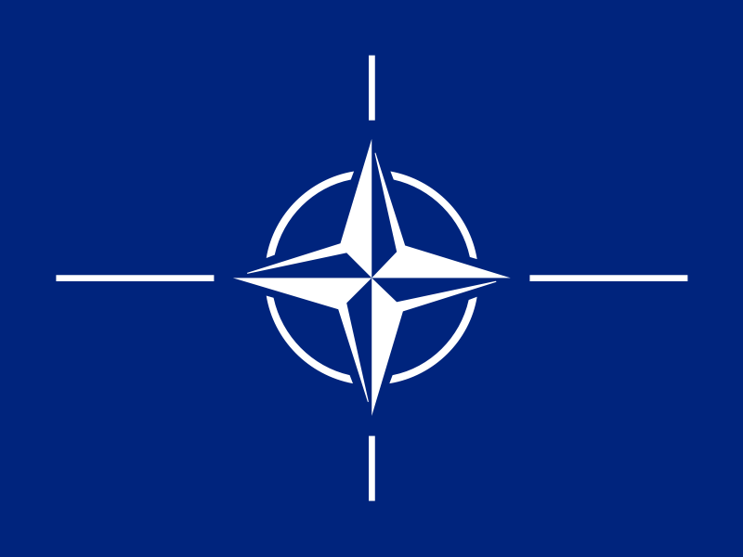
In 1966 Charles de Gaulle removes French armed forces from NATO's integrated military command to pursue its own nuclear defence programme. All non-French NATO troops are forced to leave France. This precipitates the relocation of the NATO Headquarters from Paris, France to Brussels, Belgium by October 16, 1967. However, France remained a member of NATO, notwithstanding it withdrew from the integrated military command. While the political headquarters are located in Brussels, the military headquarters, the Supreme Headquarters Allied Powers Europe (SHAPE), are located just south of Brussels, in the town of Mons.
Following France Greece also withdrew its forces from NATO's military command structure from 1974 to 1980 as a result of Greco-Turkish tensions following the 1974 Cyprus dispute.
In 1978 NATO countries defined two complementary aims of the Alliance, to maintain security and pursue detente. In 1982 Spain joins the alliance. On October 3, 1990, with the reunification of Germany, the former East Germany becomes part of the Federal Republic of Germany and the alliance. To secure Soviet approval of united Germany remaining in NATO, it is agreed that there will be no new foreign military bases in the east, and that nuclear weapons will not be permanently stationed there. On March 31, 1991 the Warsaw Pact comes to an end. It is officially dissolved on July 1, 1991. The Soviet Union collapses in December of the same year.
In 1994 NATO takes its first military action, shooting down two Bosnian Serb aircraft violating a UN no-fly zone over central Bosnia and Herzegovina. NATO airstrikes the following year help bring the war in Bosnia to an end, resulting in the Dayton Agreement. In 1997 three former communist countries, Hungary, the Czech Republic, and Poland, are invited to join NATO. They joined in 1999. The same year NATO sees its first broad-scale military engagement in the Kosovo War, where it wages an 11 -week bombing campaign against what was then the Federal Republic of Yugoslavia, aimed at preventing the alleged ethnic cleansing of Albanians. It ends on June 11,1999, when Yugoslavian leader Slobodan Milosevic agrees to NATO's demands.
During the Prague summit in 2002, seven countries are invited to start talks in order to join the Alliance: Estonia, Latvia, Lithuania, Slovenia, Slovakia, Bulgaria, and Romania. The invited countries joined NATO on March 29, 2004. Further countries expressed the wish to join the alliance, including Albania, the Republic of Macedonia, Ukraine and Croatia.
On March 29, 2004 Bulgaria, Estonia, Latvia, Lithuania, Romania, Slovakia, and Slovenia joined NATO. NATO Summit 2006 took place in Latvia.
There are currently 28 member states of NATO, with the most recent being Albania and Croatia who joined in April 2009. The combined military spending of all NATO members constitutes over 70% of the world's defense spending. The United States alone accounts for 43% of the total military spending of the world and the United Kingdom, France, Germany, and Italy account for a further 15%.

Ex. 1 Answer the questions.

1. What is the NATO?
2. When was the NATO established?
3. What were the initial members in the NATO?
4. How many members were there in the NATO initially?
5. What were the purposes of the NATO creation?
6. What was the main aim of the NATO in its earliest years?
7. When did the NATO take its first military action?
8. What city is the political headquarters of the NATO?
9. When did Spain join the alliance?
10. Is France a member of the NATO?
11. What were the countries that joined the NATO in 1997?
12. Do you want Ukraine to join the NATO?

Ex. 2 Fill in the table.

NAME OF ORGANIZATION
DATE OF CREATION
HEADQUARTERS CITY
NUMBER OF STATES
OFFICIAL LANGUAGES
PRINCIPAL ORGANS
PURPOSE. AIMS
ACTIVITIES

Ex. 3. Think of the reasons for the NATO creation. You may use the following.

defense
reaction on the USSR threat

reduce international tension
prevent occupation

maintain security
invasion
persue detente

launch an attack

nuclear arms race

disarmament

Ex.4. Give grounds for and against the existence of the NATO. If you think the organization is not necessary, say why.

FOR AGAINST
_______________________________________ _________________________________
_______________________________________ _________________________________
_______________________________________ _________________________________

Act out the following dialog.

International organizations and international cooperation

- What international organizations do you know?
- The formation of international organizations has been a 20th- century phenomenon. Nowadays there are more than 2,500 international organizations. Among them are more than 130 intergovernmental unions. The United Nations Organization is the most notable. Other important organizations are the European Economic Community, the North Atlantic Treaty Organization, the Organization of American States, and the Council for Mutual Economic Assistance.
- Why did people create international organizations?
- The creation of international organizations on a wide scale in the 20th-century is the result of the progress in the technology of communication, transportation, warfare, and the spread of industrialization. These developments gave rise to a sense of interdependence among the peoples of the world, and made people recognize the importance of international co-operation to avoid the dangers, solve the problems, and use the opportunities which confront the society of nations on a world-wide scale. Some organizations are concerned only with single and relatively narrow problems, while others, such as the United Nations and the UNESCO, deal with a great variety of matters. Moreover, international organizations function as either intergovernmental or nongovernmental agencies.
- Can you dwell on one of the international organizations?
- Yes, I can tell you about the European Union.
- When was the European Union created?
- The European Union was created November 1, 1993 out of the European Economic Community.
- How did the European Economic Community come into being?
- The European Economic Community (EEC) was founded in 1957-58 to oversee the economic integration of the nations of Western Europe. In 1967 the EEC united together with the European Coal and Steel Community and the European Atomic Energy Community to form the European Communities, or EC.
- What are member-states of the European Union?
- The European Union is an organization of most of the states of western Europe that works toward and oversees the economic and political integration of these states. The European Union consists of the European Community. The original members of the EEC were Belgium, France, West Germany, Italy, Luxembourg, and the Netherlands. Denmark, Ireland, and the United Kingdom joined in 1973. Greece was admitted in 1981. Portugal and Spain entered in 1986. The former East Germany entered as part of re unified Germany in 1990. Greenland, a dependent state of Den mark that had been brought into the EC when under full Danish rule, withdrew in 1985. The Maastricht Treaty paved the way for other European countries to join the EU. Austria, Finland, and Sweden - all members of the European Free Trade Association (EFTA) - became members of the EU in 1995.
- How often do the members of the European Union meet?
- The European Union General Assembly meets once in four years. As a rule the European Union member-states have regular annual meetings.
- What role do the international organizations play today?
- The influence of the international organizations is great. They deal with political, social, and economic problems. They are concerned with the environmental problems as well. For example, such international organization as the United Nations is aimed at modifications of the national and international laws for the good of the people. The chief modification introduced by the United Nations Charter is the limitation of the rights of subjects of international law under international customary law to threaten or resort to armed reprisals and war.
- What are the results of the activity of the international organizations?
- The results of the activity of the international organizations are significant The UN General Assembly passed a number of resolutions and declarations. They are the Nuremberg Principles that dealt with crimes against peace, war crimes, and crimes against humanity; genocide; the Universal Declaration of Human Rights; the right of peoples and nations to self-determination; permanent sovereignty over natural resources; denuclearization; and non-intervention. The most important of them is the Universal Declaration of Human Rights. This general agreement that all human beings are entitled to some basic rights marked the birth of the international and universal recognition of human rights.

Belarus On The International Arena

INTERNATIONAL COOPERATION

Belarus was admitted to the United Nations on 22 October 1945 and serves on several specialized agencies, such as IAEA, IMF, UNCTAD, UNESCO, UNIDO, WHO, and the World Bank. It is an observer in the WTO. Belarus joined the OSCE on 30 January 1992. The country is part of the Commonwealth of Independent Nations (CIS) and the Central European Initiative. In 2000, Belarus, Kazakhstan, Russia, Kyrgyzstan, and Tajikistan established the Eurasian Economic Community.
The country has signed the Nuclear Nonproliferation¹ Treaty and has formal diplomatic ties with many nations. It is a member of the Nuclear Suppliers Group (London Group) and the Nonaligned Movement². The country is also a member of the NATO Partnership for Peace. The United States recognized Belarus's sovereignty 25 December 1991. US diplomatic relations with Belarus were established two days later. Belarus has unresolved boundary disputes with Ukraine and Latvia.
In environmental cooperation, Belarus is part of the Basel Convention, the Conventions on Biological Diversity and Air Pollution, Ramsar, CITES, the London Convention, the Montréal Protocol, MARPOL, and the UN Conventions on Climate Change and Desertification.

FOREIGN TRADE

Before the collapse³ of the Soviet Union, Belarus exported about 40% of its industrial output to other Soviet republics and imported 90% of its primary energy and 70% of its raw materials from them. Belarus has remained exceedingly⁴ dependant on Russia for economic support; a proposed EU-style partnership between the two nations threatens its economic independence.
In 2000, Belarus exported machinery and transport equipment, chemicals, petroleum products, and manufactured goods. Imports included fuel, natural gas, industrial raw materials, textiles, and sugar. Belarus's major trading partners are Russia, Ukraine, Poland, and Germany. Imports and exports grew at an annual pace of over 61% in 1995.
Unlike Russia, Belarus did not manage to maintain a positive resource balance in 2004—while exports grew to $11.5 billion (FOB—Free on Board), they were surpassed by imports, at $13.6 billion. Russia continued to dominate Belarus's trade, receiving 47% of its exports, and sending 68.2% of its imports. Other important trading partners included the United Kingdom, Germany, the Netherlands, and Poland.
As a sovereign country, Belarus enjoys full rights and is active on the foreign arena. From the moment of setting up the United Nations Organization (UNO) Belarus as one of its constituent member states takes an active part in the work of this association, its organs and institutions. Belarus regularly sends its delegations to the sessions of the UNO General Assembly, has its permanent delegation and its own staff in it. Belarus is a member of some international specialized organizations, commissions, bureaus, funds and other organs.
On the initiative of Belarus the international organizations have adopted a number of important decisions, particularly on the punishment of war criminals, on education of youth in the spirit of ideas of peace and friendship among nations. Belarus has signed many treaties, agreements, protocols and conventions on cooperation with other countries in various fields. Belarus has many a time been the seat of convening⁵ international meetings, such as UNO seminars on social aspects of industrialization and on distribution of industry, seminars on the International organization of labor, on inspection of labor, etc. Together with representatives of other peace-loving countries the envoys⁶ of Belarus are struggling for implementing⁷ a policy that answers the basic interests of all nations of the world, for their peace and security, cooperation and friendship.
The Belarusian people indefatigably⁸ strengthen and broaden its ties with the people of other countries. Its public organizations have established direct contacts and exchange delegations with their trade unions, youth, women's and sports organizations. Fruitful are the activities of the Belarusian Society for Friendship and Cultural Relations with foreign countries. It maintains contacts with many organizations of many countries.

Foreign relations

Belarus and Russia have been close trading partners and diplomatic allies since the breakup of the Soviet Union. Belarus is dependent on Russia for imports of raw materials and for its export market. The Union of Russia and Belarus, a supranational⁹ confederation, was established in a 1996–1999 series of treaties that called for monetary union, equal rights, single citizenship, and a common foreign and defense policy. Although the future of the Union was in doubt because of Belarus' repeated delays of monetary union, the lack of a referendum date for the draft constitution, and a 2006–2007 dispute about petroleum trade, on December 11, 2007, reports emerged that a framework for the new state had been discussed between both countries.
Belarus was a founding member of the Commonwealth of Independent States (CIS). The country has trade agreements with several European Union member states, as well as with its neighbors Lithuania, Poland and Latvia.
Belarus and the United States cooperate on intellectual property protection, prevention of human trafficking and technology crime, and disaster relief¹⁰.
Belarus has increased cooperation with China, strengthened by the visit of President Lukashenko to that country in October 2005. Belarus has strong ties with Syria, which President Lukashenko considers a key partner in the Middle East. In addition to the CIS, Belarus has membership in the Eurasian Economic Community and the Collective Security Treaty Organization. Belarus has been a member of the international Non-Aligned Movement since 1998 and a member of the United Nations since its founding in 1945.

FOREIGN RELATIONS

Under an arrangement with the former U.S.S.R., Belarus was an original member of the United Nations. It also is a member of the Commonwealth of Independent States (CIS - a group of 12 former Soviet republics) and its customs union, the Belarusian and Russian Union State, the Eurasian Economic Community, the Collective Security Treaty Organization (CSTO), the Organization for Security and Cooperation in Europe (OSCE), the North Atlantic Treaty Organization's (NATO) Partnership for Peace, the North Atlantic Cooperation Council, the Non-Aligned Movement, the International Organization for Migration (IOM), the International Monetary Fund, and the World Bank.

Following the recognition¹¹ of Belarus as an independent state in December 1991 by the European Community, EU-Belarus relations initially experienced a steady¹² progression. The signature of the Partnership and Cooperation Agreement (PCA) in 1995 signaled a commitment to political, economic, and trade cooperation. Significant assistance was provided to Belarus within the framework¹³ of the TACIS technical assistance program and also through various aid programs and loans¹⁴.

Russia is the single largest partner for Belarus in the economic and political fields. In terms of trade, one-third of Belarusian exports go to Russia. Due to the structure of Belarusian industry, Belarus relies heavily on other CIS countries, and Russia in particular, both for export markets and for the supply of raw materials, subsidized energy, and components.

The framework for the Russia-Belarusian “Union State” was set out in the Treaty on the Formation of a Community of Russia and Belarus (1996), the Treaty on Russia-Belarus Union, the Union Charter (1997), and the Treaty of the Formation of a Union State (1999). The integration treaties contain commitments to monetary union, equal rights, single citizenship, and a common foreign and defense policy. They also have established a range of institutions modeled after the EU. With the exception of isolated progress, such as unification¹⁵ of the two countries' customs duties in March 2001, the Union State has not moved forward.

¹nonproliferation нераспространение ядерного оружия ²Nonaligned Movement движение неприсоединения

³collapse распад, развал ⁴exceedingly весьма, очень сильно ⁵convening созываемых ⁶envoys [`envOI] посланники ⁷implementing обеспечение выполнения ⁸indefatigably неустанно ⁹supranational наднациональный ¹⁰relief снижение ¹¹recognition признание ¹²steady устойчивый ¹³framework остов, основа ¹⁴loan заем; ссуда; документ ¹⁵unification слияние

International organization membership

Ex. 1. Look at the list of international organization membership of the Republic of Belarus and choose 5 major organizations in your opinion. Share your choice with your classmates.
The Republic of Belarus is a member of:
- Black Sea Economic Cooperation Zone (BSEC) (observer)  - Central European Initiative (CEI)  - Collective Security Treaty Organization (CSTO)  - Commonwealth of Independent States (CIS)  - Eurasian Economic Community (EAEC)  - Euro-Atlantic Partnership Council (EAPC)  - European Bank for Reconstruction and Development (EBRD)  - Food and Agriculture Organization (FAO)  - General Confederation of Trade Unions (GCTU)  - International Atomic Energy Agency (IAEA)  - International Bank for Reconstruction and Development (IBRD)  - International Civil Aviation Organization (ICAO)  - International Criminal Police Organization (Interpol)  - International Development Association (IDA)  - International Federation of Red Cross and Red Crescent Societies (IFRCS)  - International Finance Corporation (IFC)  - International Labour Organization (ILO)  - International Mobile Satellite Organization (IMSO)  - International Monetary Fund (IMF)  - International Olympic Committee (IOC)  - International Organization for Migration (IOM)  - International Organization for Standardization (ISO)  - International Red Cross and Red Crescent Movement (ICRM) | - International Telecommunication Union (ITU)  - International Trade Union Confederation (ITUC)  - Inter-Parliamentary Union (IPU)  - Multilateral Investment Guarantee Agency (MIGA)  - Nonaligned Movement (NAM)  - Nuclear Suppliers Group (NSG)  - Organization for Security and Cooperation in Europe (OSCE)  - Organization for the Prohibition of Chemical Weapons (OPCW)  - Partnership for Peace (PFP)  - Permanent Court of Arbitration (PCA)  - United Nations (UN)  - United Nations Conference on Trade and Development (UNCTAD)  - United Nations Educational, Scientific, and Cultural Organization (UNESCO)  - United Nations Industrial Development Organization (UNIDO)  - Universal Postal Union (UPU)  - World Customs Organization (WCO)  - World Federation of Trade Unions (WFTU)  - World Health Organization (WHO)  - World Intellectual Property Organization (WIPO)  - World Meteorological Organization (WMO)  - World Tourism Organization (UNWTO)  - World Trade Organization (WTO) (observer)
Ex. 2. Speak about economic ties of Belarus with foreign countries. Make a list of goods Belarus imports and exports. Comment on your choice.

GOODS IMPORTED GOODS EXPORTED
_________________________________ ________________________________
_________________________________ _______________________________
_________________________________ _______________________________
________________________________ ___ _______________________________
_________________________________ _______________________________

Ex. 3. Answer the questions.

1. When was Belarus admitted to the United Nations?
2. What international organizations is Belarus a member of?
3. What goods did Belarus export in 2000?
4. What are the relations of Belarus with the UN?
5. What countries does Belarus have the strongest ties with? In what spheres of economy does it cooperate with other countries?
6. In what spheres does Belarus cooperate with the USA?

